Data Ethics Canvas

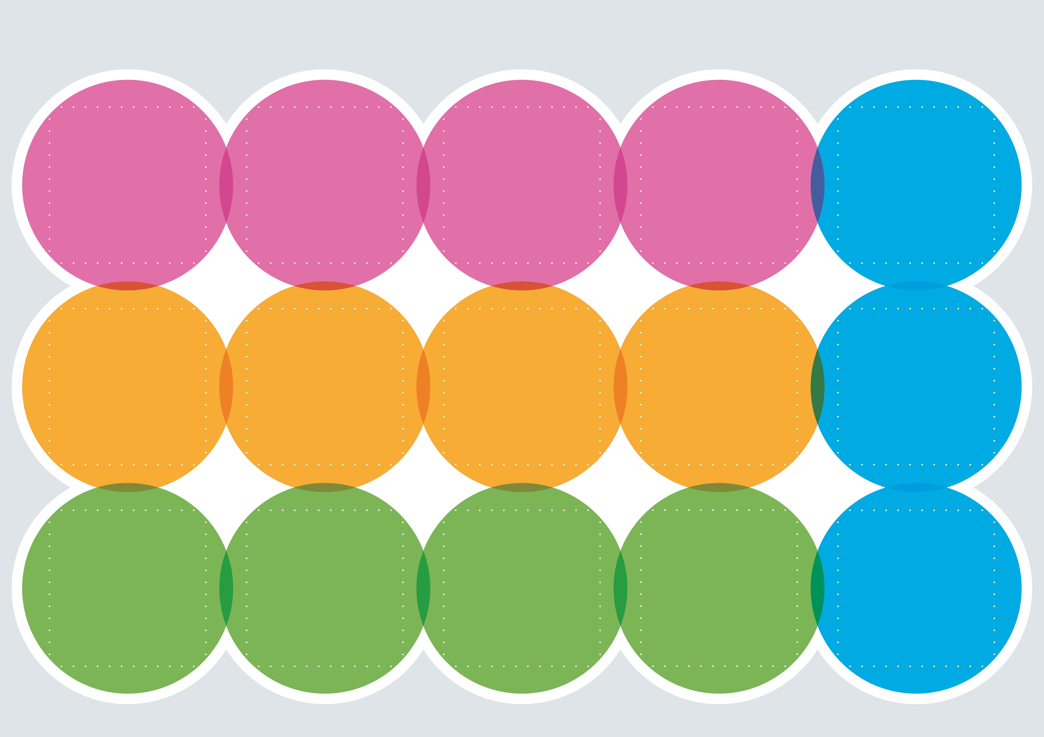

2022-11

# Ongoing implementation

Patients’ experience is at the center of the project and is always taken in consideration by asking them about their health and wellbeing and feedback about the treatment. They are informed and asked consent with questionnaires before experiments.

# Data Sources

My project’s key data sources are data obtained at the hospital then handed to ZHAW researchers. Personal and sensitive information about patients’ health is involved.

# Rights around data sources

I get the data from doctors of patients and from researchers at the Hospital lab. It is firstly collected from individuals, then provided by the organization USZ to ZHAW. The data is collected initially for medical purposes only, then for research purposes secondarily. I have permission using this data under condition of confidentiality in the frame of the research project.

# Limitations in data sources

There is possible bias in data collection by the doctors/researchers. There is possible gaps or omission in data due to human factor (such as sick researcher).

# Ethical and legislative context

The same ethical codes that apply at the hospital apply in my project. The framework is specific to the health sector.

**Minimizing negative impact**

The anonymization of patients is part of the data handling. It is regularly checked by the principal investigator that researchers follow this regulation. These measures allow us to keep a trustworthy relationship with patients and continue the project safely.

Based on patients’ feedback and on regular checks of the data set, the ongoing data ethics code will be updated. In the beginning of the project this canvas will be discussed and updated monthly, then when the situation is stable, yearly.

**Reviews and iterations**

**Positive eﬀects on people**

A leak of personal information could cause harm to individuals participating in the project (patients). If the data is called without anonymization, it can cause harm or expose individuals to risk of being re- identiﬁed. It could be then used to target, proﬁle or prejudice these patients and cause financial or reputational harm. These limitations are communicated to patients through a consent form.

**Negative eﬀects on people**

Patients suffering from delirium, as well as their families and care givers will be positively affected by this project. Improvement in treatment will reduce duration, frequency, and intensity of crisis. Research organization and hospitals will receive notoriety and funds for solving a medical concern.

# Your reasons for using data

Our primary purpose for collecting and using data in this project is the wellbeing of patients and progress in science and medicine. This project can help developing better drug and therapies for people suffering from the given condition.

# 

**Engaging with people**

People from outside the hospital or third parties can write an email to the principal investigators or to any researcher from the research group at ZHAW or the USZ. It is available on the Hospital’s website. The participants of the study can ask questions or correct information at any time of the experiment.

**Communicating your purpose**

Patients understand the purpose of the study and voluntarily participate in it by signing the consent form. The purpose and the legal and ethical implications are communicated in this form. It is also orally explained to them by the doctors/researchers at the beginning

of the project.

**Openness and transparency**

The methodology, metadata, datasets, code or impact measurements can be published and shared for further research purposes as long as it is anonymized.

# 

**Your actions**

The plan of further actions is especially available for the grants/funds organizations. They will not be publicly published before getting funding.

**Sharing data with others**

The data will be shared between USZ and ZHAW fluently. To share it with other research organizations one can formulate a request. The main results and findings are published publicly under condition of anonymity.

# 